The most endangered frog in the Czech Republic will finally get help

Press release

Project:
Preparation of a action programme for natterjack toad (Epidalea calamita)

Project from the Small grant scheme „Action programmes for particularly endangered species II"

Recently, critically endangered natterjack toad has been one of the most threatened and disappearing species in the Czech Republic. Its occurrence was recorded only in some localities of Bohemia, and moreover in small sparse colonies. Formerly, it populated smaller sandpits, where it reproduced in shallow uncovered pools. The current deep pools in sanpits are not suitable for this species. The toad also used puddles in hop fields and root crop fields. Cereals and other crops with dense growth form an impenetrable barrier for this species. Due to its short hindlimbs, the frog does not like jumping and moves mostly by crawling or trotting. In contrast to the common toad or European green toad, the natterjack toad carries a light vertical line through the middle of its back.
To preserve it as part of the fauna in the Czech Republic, human help will be needed in the form of creating small pools in sandpits, quarries and similar unforested stations. Fortuntely, natterjack toad has been selected among several species for which a salvage programme will be implemented. Preparation of this salvage programme for this year was placed into the hands of organization HERPETA. However, the fate of this species in the future will also depend on the understanding and cooperation from the side of owners of sandpits, quarries, tankodromes, decantation plants and other land types.

For more information see: www.herpeta.cz, www.zachranneprogramy.cz

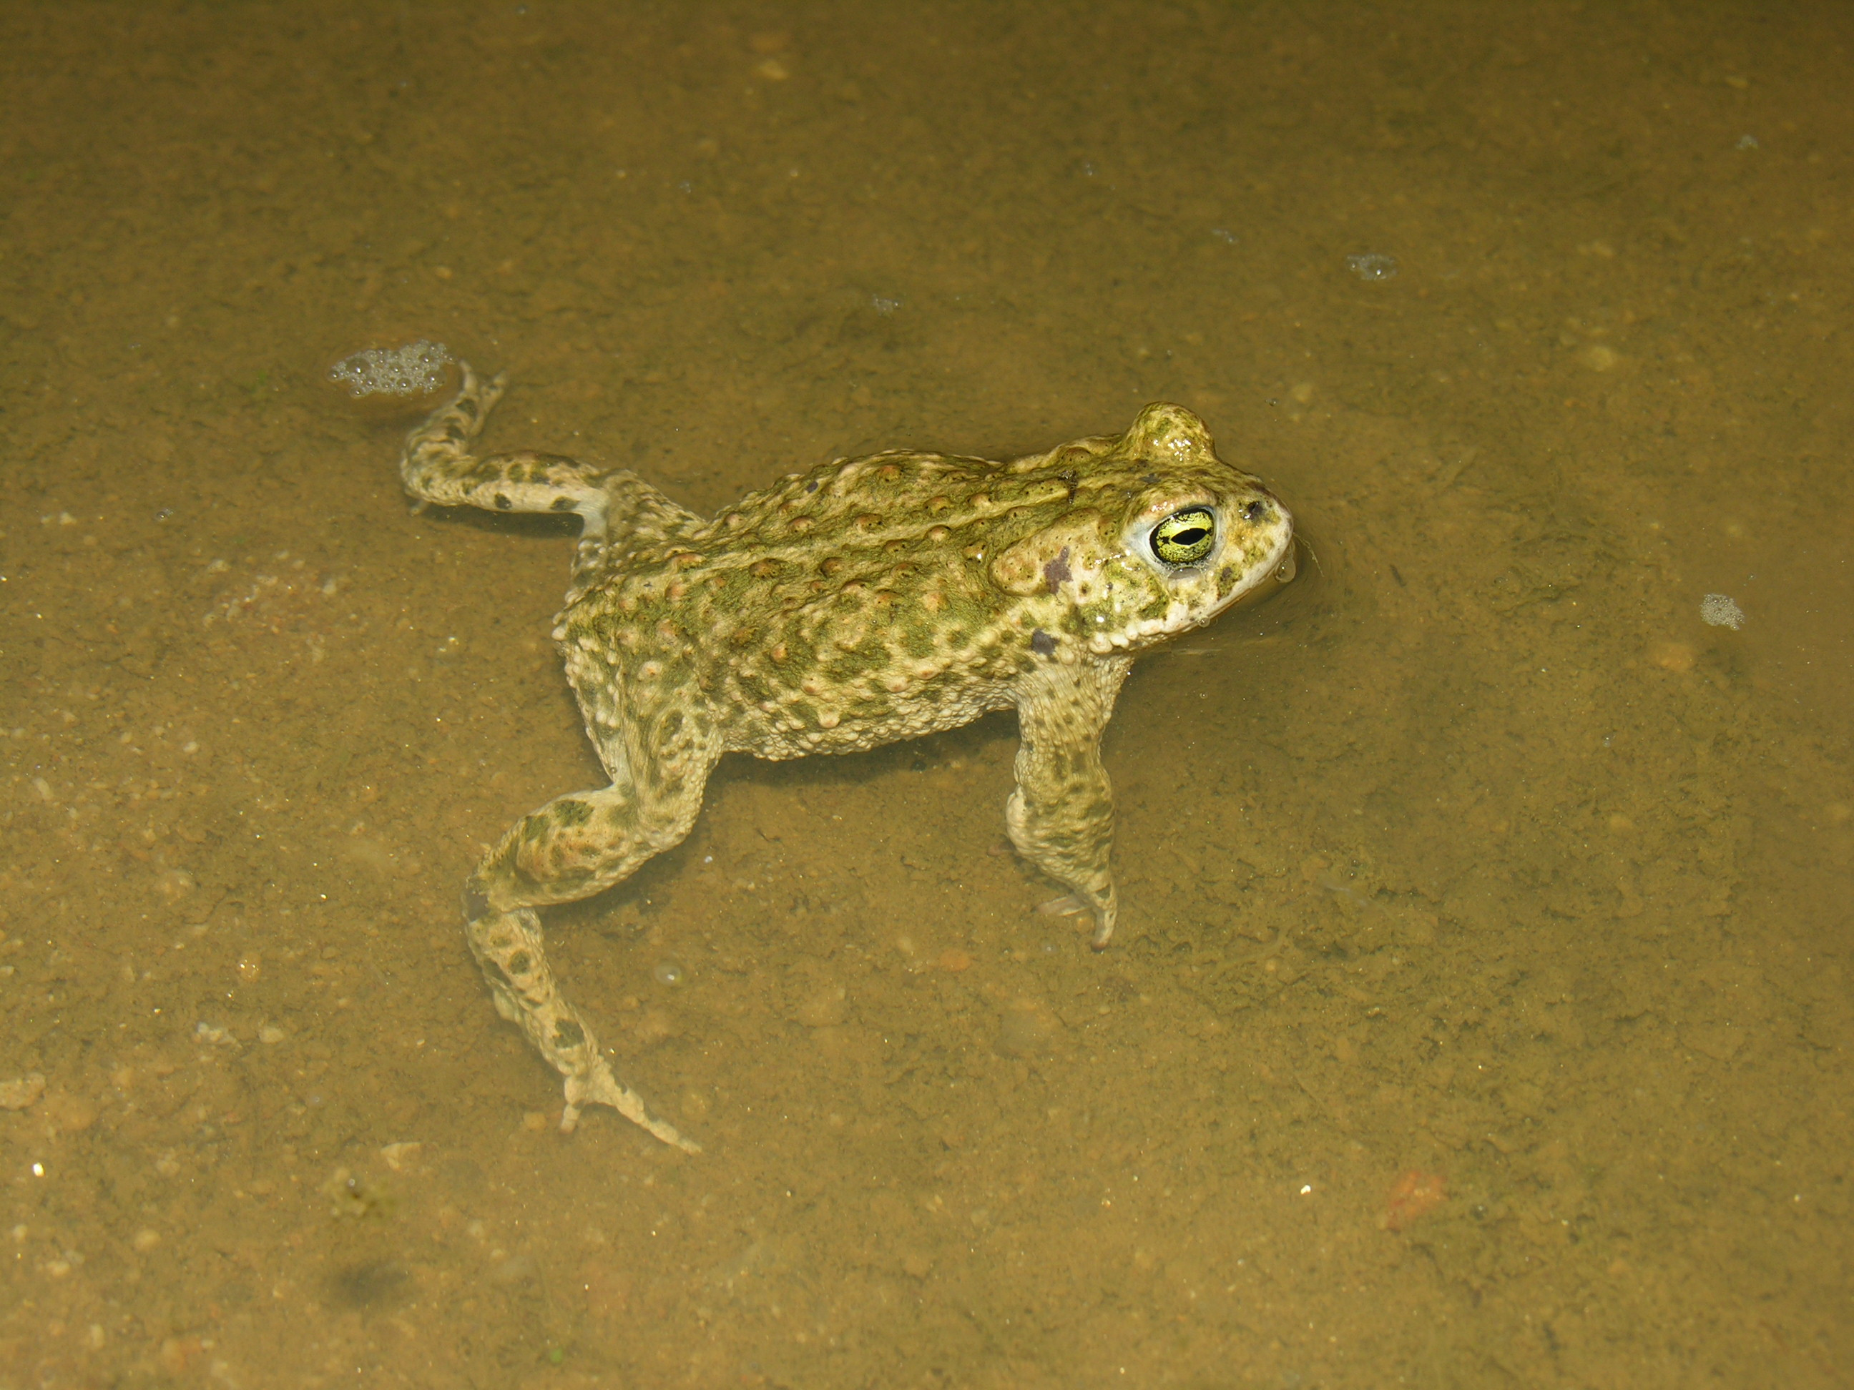.

This document was created with financial support from EEH funds 2009-2014 and from the Ministry of the Environment of the Czech Republic. The content of this document is the sole responsibility of HERPETA and in no case can be considered as the opinion of the sponsor or the Ministry of Environment.

